**Avoid Direct Field Overwriting:**

Overwriting an existing field like name can sometimes cause issues. A safer approach is to use the _modify_attrs method (Odoo 17+) or override the field using related attributes.

**Correcting Field Modification (Pre-Odoo 17)**

If you are using Odoo 16 or earlier, you should override the field properly in the class like this:

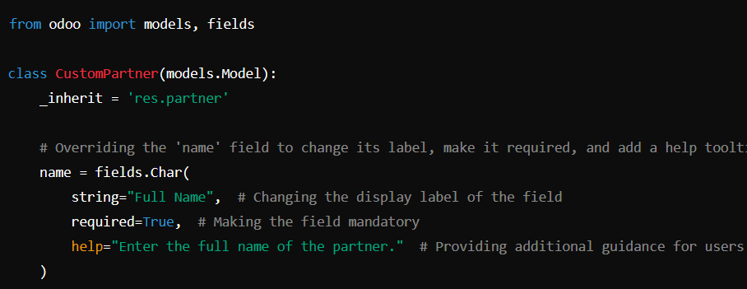

* readonly=False is unnecessary because fields are editable by default.
* Ensure that modifying name does not conflict with built-in logic.

**Using _modify_attrs for Odoo 17+** If you are working with Odoo 17 or later, use:

